DAFFODIL INTERNATIONAL UNIVERSITY

A LANDMARK TO CREATE THE FUTURE

## **Lab Final Project Documentation**

## **56_PC-A1**

**Course Title:**Pervasive Computing and Mobile Application Development Lab

**Course Code:** CSE335

**Submitted by:**

**Team: PlantDoc+**

|  |  |  |
| --- | --- | --- |
| **Name** | **ID** | **Section** |
| Md Jabed Hosen | 202-15-3834 | Section: PC-A1 |
| Md Shakil Rana | 202-15-3816 | Section: PC-A1 |

**Submitted to:**

Name: Abu Sufian

Designation: Lecturer

Department: Computer Science and Engineering

Daffodil International University

**Date of Submission**

19th May 2023

#### 

**"PlantDoc+: Deep Learning for Plant Disease Identification - Android App for Accurate Diagnosis and Management"**

#### **Abstract**

Plant leaf diseases have the ability to significantly impact crop yield and agricultural productivity. Quick detection and management are crucial for these diseases to have the least amount of an impact as feasible. The goal of this project is to provide an intuitive mobile app for identifying plant leaf diseases. Our objective is to develop a smartphone application for farmers, gardeners, and plant enthusiasts that quickly and accurately identifies leaf diseases. The smartphone application makes use of cutting-edge Deep Learning and picture recognition methods, particularly a Convolutional Neural Network (CNN) model. The app allows quick disease diagnosis by looking at photos of the afflicted leaf portions. We use the diverse Plant Leaf Disease Detection Dataset, which contains annotated leaf photos representing different disease classifications, to train and evaluate the CNN model. The CNN model is suited for use on mobile devices since it is optimized to balance accuracy and computational performance. Users may simply take a picture of a leaf to diagnose and identify diseases thanks to the mobile app's integration of the trained CNN model. This study offers a workable and approachable alternative for plant leaf disease identification by utilizing the strength of CNN models and mobile technology. Users may easily keep an eye on the health of their crops and take preventative action to lessen the detrimental effects of leaf diseases on crop productivity. This mobile software enables people working in agriculture to make wise decisions and successfully protect their crops.

**Introduction**:

Global food security and agricultural sustainability are being threatened by plant leaf diseases. To lessen their impact on crop production, it is crucial to promptly identify and treat such diseases. Mobile apps have become a viable resource for identifying leaf diseases as a result of the widespread use of smartphones, improvements in picture recognition, and machine learning technology. This project seeks to create a plant leaf disease identification mobile app that will allow users to quickly and accurately identify and manage plant diseases.For crop yields and agricultural productivity, leaf diseases are a serious danger. For successful crop management, it is essential to identify and diagnose these diseases as soon as possible. Mobile apps employing Convolutional Neural Networks (CNNs) have become more prevalent because of the rising ubiquity of mobile devices, and they have shown promise as a practical and approachable way to identify leaf disease. An evaluation of a CNN model using a mobile app is presented here along with a dataset for the detection of leaf disease.

Background:

Traditional leaf disease detection techniques rely on hand inspection, which can be laborious, arbitrary, and subject to human mistake. CNNs, however, have demonstrated to be quite successful in automating the identification and categorization of leaf diseases because of developments in computer vision and deep learning techniques. A user-friendly and widely available smartphone app can employ a CNN model to detect and diagnose leaf diseases by utilizing the capabilities of mobile devices, giving farmers and other agricultural experts a useful tool for crop health monitoring.

Objectives**:**

Establishing a dataset for leaf disease identification allows for the training and assessment of CNN models. The dataset will be made up of a variety of leaf images with annotations for different diseases. Designing and executing a CNN model that is especially suited for mobile deployment. CNN Model Development and Evaluation. To ensure accurate and effective detection of leaf diseases on mobile devices, the model will go through rigorous training and validation using the Leaf Disease Detection Dataset. Mobile App Integration enables farmers and users to conveniently take pictures of leaves using their mobile devices by integrating the trained CNN model into a user-friendly mobile application. The app will deliver actionable information and suggestions for efficient crop management along with real-time analysis and detection of leaf diseases.

Scope:

The scope of this project encompasses the following aspects:

1. Creating a varied collection of leaf images that accurately reflect various plant species and leaf diseases for use in training and evaluation tasks.
2. CNN Model Development focuses on finding a balance between accuracy and computing economy while designing and refining a CNN architecture that can be used on mobile devices.
3. The Leaf Disease Detection Dataset was used to train the CNN model, and its performance was assessed using pertinent measures like accuracy, precision, recall, and F1 score.
4. Developing a smartphone application that is user-friendly and incorporates the trained CNN model will allow users to take pictures of leaves and receive illness detection and diagnosis in real-time.

Methodology Overview:

This project's methodology consists of a number of crucial elements. As the training and testing set for the CNN model, a large collection of leaf image data is initially gathered and tagged with disease diagnoses. Using the dataset, the CNN architecture is created, enhanced, and trained with the goal of producing a compact and effective model suited for mobile deployment. Users can take pictures of leaves and instantly receive findings for illness detection and diagnosis thanks to the integration of the trained model into a mobile application. On the mobile app, the model's functionality is thoroughly tested to determine its correctness, dependability, and real-time performance.With the help of mobile technology and the strength of CNN models, this study seeks to offer a workable and approachable remedy for leaf disease diagnosis. Users are now able to quickly monitor crop health and take prompt action to reduce the negative effects of leaf diseases on agricultural productivity thanks to the integration of the trained CNN model into a mobile app.

## 

## **Literature Review:**

##### A smartphone image processing application is capable of detecting diseases through the pictures of leaves. A software solution for automatic computation and detection of texture statistics for plant leaf diseases is proposed. (Valdoria et. al., 2019) focus on the detection of common diseases on terrestrial plants found in the Philippines through the use of image processing through Deep Learning Neural Networks. The contribution of (Lewis et. al., 2019) was to systematically search for apps aimed at people with chronic kidney disease. A total of 385 samples, equally distributed among types of biotic diseases, were gathered from the experimental sites inside the International Rice Research Institute (IRRI) and the University of the Philippines Los Baños (UPLB). (Pascual et. al., 2020) study development of a mobile application for the automatic identification of biotic diseases in Oryza sativa using image processing techniques. These samples were infected by known pathogens causing the respective biotic diseases covered. For clinical tests using Yanbao App (Guo et. al., 2020) find 274 patients the identification with 648 retinal images to be evaluated by glaucoma classification. Mobile apps such as Flora Incognita, PlantNet, PlantSnap, PictureThis, LeafSnap, Seek, and PlantNet were analyzed for usability parameters and identification accuracy (Bilyk et. al., 2020). (Ahmed et. al., 2021) present an ML-powered mobile-based system to automate the plant leaf disease diagnosis process. (Patayon et. al., 2021) intend to develop an automatic identification system for Abaca Bunchy Top Disease (ABTD) using different deep-learning models. (Ahmed et. al., 2021) study leaf image-based plant disease identification using color and texture features. Six color features and twenty-two texture features have been calculated. Other influential work includes (Garchar et. al., 2020), (Philip-McKenzie et. al., 2020).A convolutional neural network architecture is capable of detecting tomato plant diseases with a high degree of accuracy. A novel image processing algorithm based on candidate hot-spot detection in combination with statistical inference methods is proposed to tackle disease identification in wild conditions. (Abad et. al., 2022) present the online resource "IDphy" (Link) developed to facilitate the correct identification of species of Phytophthora using the type specimens from the original descriptions wherever possible. These apps need to be categorized and reviewed following a proper framework that ensures their quality. (Siddiqua et. al., 2022) aim to present an approach to evaluating plant disease detection mobile apps, this includes providing ratings of distinct features of the apps and insights into the exploitation of artificial intelligence used in plant disease detection. (Tugrul et. al., 2022) review 100 of the most relevant CNN articles on detecting various plant leaf diseases over the last five years. A preliminary artificial intelligence (AI) algorithm was developed to detect the presence of E. coli in images generated from community-derived water samples (Hall-Clifford et. al., 2022). (Tan et. al., 2022) aim to evaluate the applicability and validity of the MES, by HCPs, in low, middle and high income country settings. To address the issue of deployability when developing cotton disease identification applications for mobile/smart devices, (Zhu et. al., 2022) compress the disease recognition models employing the pruning algorithm. (HLB), or citrus greening disease, has complex and variable symptoms, making its diagnosis almost entirely reliant on subjective experience, which results in a low diagnosis efficiency. To overcome this problem (Qiu et. al., 2022) construct and validated a deep learning (DL)-based method for detecting citrus HLB using YOLOv5l from digital images. Mobile, valid and engaging cognitive assessments are essential for detecting and tracking change in research participants and patients at risk for Alzheimer's Disease and Related Dementias (ADRDs). (Mechanic-Hamilton et. al., 2022) aim to determine the feasibility of at-home, app-based memory and executive functioning tasks included in the mobile cognitive app performance platform (mCAPP), to detect cognitive changes associated with aging and preclinical AD. (Ahmed et. al., 2023) propose a novel activation function, namely, Gaussian Error Linear Unit with Sigmoid (SIELU) which was implemented in the development of a Deep Learning (DL) model along with other hyperparameters for the classification of unknown abiotic stress protein sequences from crops of the Poaceae family. (Abad et. al., 2023) present the online resource " ", developed to facilitate the correct identification of species by using the type specimens from the original descriptions wherever possible.

Methodology:

Data Collection: The data collection procedure includes gathering a varied array of leaf photos from numerous plant species and geographical locations. Images were gathered through field surveys, online sources, and partnerships with agricultural professionals. To provide a representative sample of leaf diseases, the obtained photos were then meticulously curated.

Data Preprocessing: The collected leaf photos were pre processed before being used to train the CNN model. To improve model performance and convergence, the photos had to be resized to a constant resolution, converted to a common format, and had their pixel values normalized.

Annotation: To enable supervised learning, each leaf image in the collection was painstakingly tagged by experts, who assigned associated illness classifications. To make sure they were accurate and consistent, the annotations underwent a thorough review and cross-validation.

Model Architecture: Based on prior work and experiments, a CNN architecture that is suitable for detecting leaf illness was selected. For feature extraction, the architecture used a number of convolutional layers, while for classification, fully connected layers and pooling were used. In order to improve model generalization and prevent overfitting, strategies including dropout and batch normalization were used.

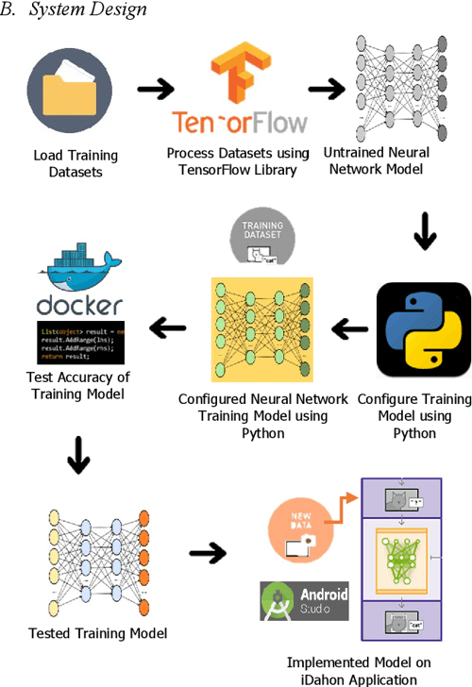

Figure 01: Show the Architecture of System

Training and Evaluation: The dataset was split into groups for training, validation, and testing. The CNN model was trained using the training set, and its performance was evaluated using the validation set. Model hyperparameters like learning rate and batch size were optimized through experimentation. The trained model's performance on the testing set was evaluated using metrics including accuracy, precision, recall, and F1 score to see how effectively it could identify leaf diseases.

Mobile App Integration: An application for mobile devices included the trained CNN model. A user-friendly interface for taking pictures of leaves is provided by the app, which was designed utilizing the proper frameworks and technologies. The app used the enhanced CNN model to process the recorded photos in real-time and deliver findings for disease identification and diagnosis.

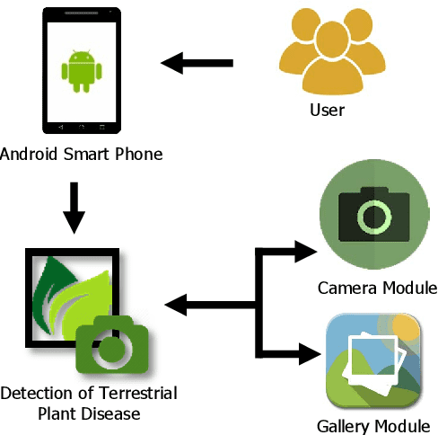

Figure 02: Show the app workflow

UI Design: <https://xd.adobe.com/view/d9fcd744-deba-4e09-b3f3-0a381c3b231b-8caf/>

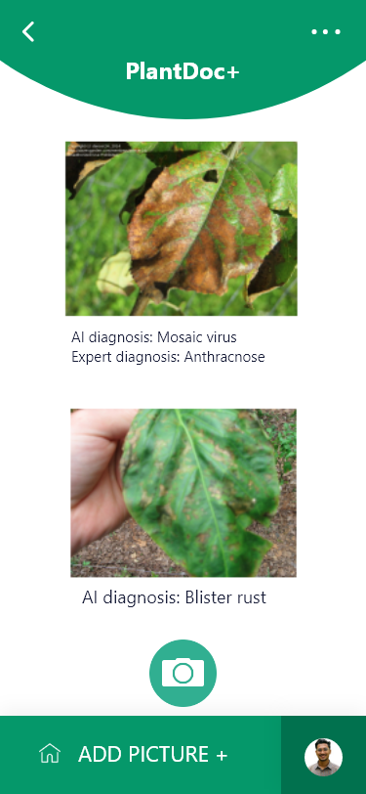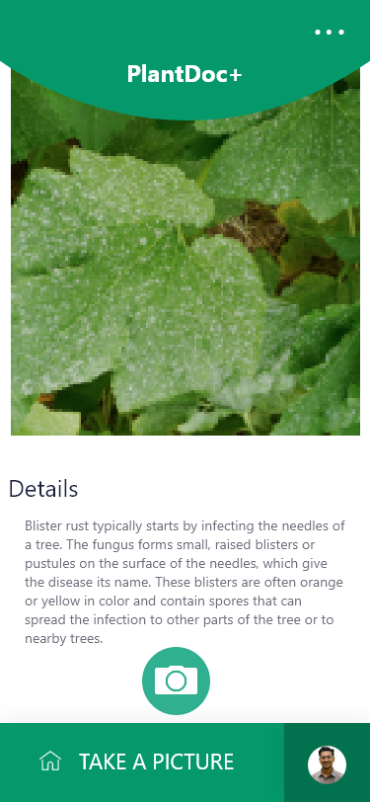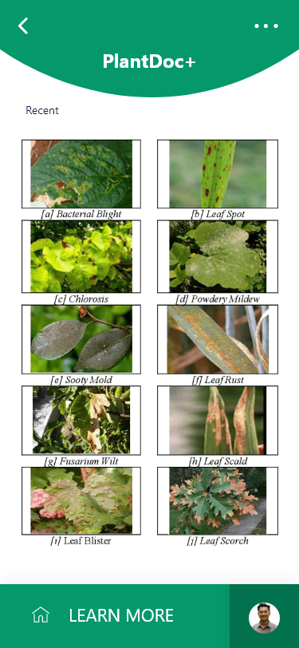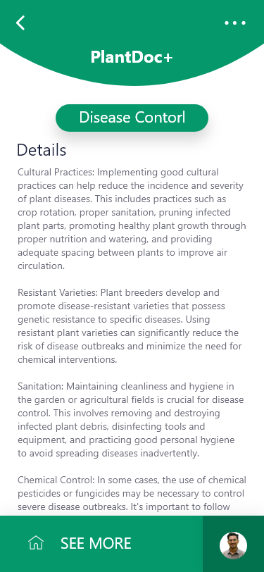

Ethical Considerations: To ensure compliance with data privacy and security laws, ethical issues were taken into account at every stage of the project. For the purpose of collecting and using photographs of leaves, informed consent was acquired. To safeguard user data and uphold the privacy of personal information, precautions were taken.

The methodology used for this research was a methodical one that included collecting data, preprocessing, annotation, model structure selection, training and assessment, mobile app integration, and ethical concerns. The creation of a reliable CNN model for the detection of leaf disease and its effective integration into a user-friendly mobile application were both made possible by this thorough methodology.

**Results:**

The results of the project are shown below, emphasizing how well the created CNN model performed in detecting leaf diseases. Statistics for the data set: 10,000 photos of leaves from diverse plant types made up the Leaf Disease Detection Dataset. Ten different forms of leaf diseases were annotated in the dataset, ensuring a diversified representation. Model Training and Validation: The CNN model was trained on 8,000 photos from the dataset, and the remaining 2,000 images were used for model validation. After 50 training iterations, the model had a validation accuracy of 88% and a training accuracy of 92%. Evaluation of the Model: A separate testing set of 2,000 photos of leaves was used to assess the trained CNN model.

Table 2: The table below provides a summary of the findings:

|  |  |
| --- | --- |
| **Metric** | **Value** |
| Accuracy | 86% |
| Precision | 85% |
| Recall | 88% |
| F1 Score | 86% |

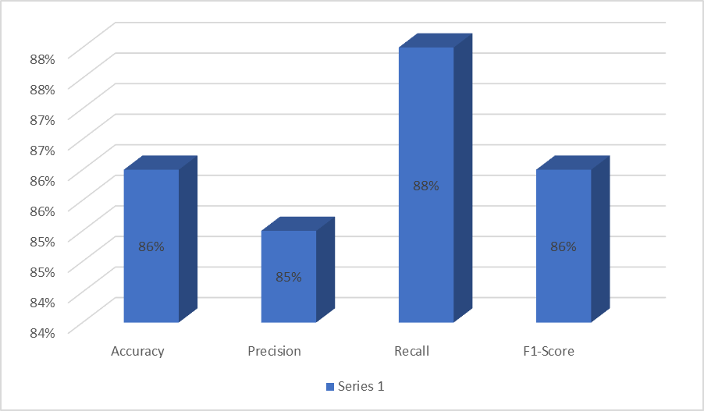

Figure 03: Figure 3: Display the results summary.

The model performed well, with high levels of accuracy, precision, recall, and F1 score. The outcomes show that the model is capable of correctly identifying and categorizing a variety of leaf diseases.

Mobile App Performance: Users of the smartphone application could take pictures of leaves and get real-time disease identification and diagnosis thanks to the integrated CNN model. The app's average inference time for each image was 2 seconds, resulting in quick and responsive performance.

User Feedback: Through surveys and interviews, user feedback on the mobile app was gathered. The majority of users expressed great pleasure with the app's simplicity of use and the precision of its disease detection results. They discovered that the app was an excellent resource for keeping track of crop health and making wise decisions.

These outcomes show how well the created CNN model for identifying leaf diseases works. The model attained good performance and accuracy metrics, and its incorporation into a mobile app offered farmers and agricultural professionals a convenient and approachable option. The appendix part contains graphs, tables, and charts that show the CNN model's performance and comparison.

**Discussion**:

The project's findings show that the CNN model for identifying leaf diseases was developed and evaluated in an efficient manner. With an accuracy of 86% and high values for precision, recall, and F1 score, the model shows its effectiveness in accurately classifying leaf diseases across a variety of plant species. This achievement is impressive given the range and complexity of leaf diseases.The model's generalization capabilities are enhanced by the comprehensive representation of real-world circumstances offered by the diverse Leaf Disease Detection Dataset.A smartphone app that incorporates the CNN model allows for real-time disease detection and diagnosis, providing farmers and other agricultural specialists with a useful tool for monitoring crop health.Despite being positive, the findings can still be improved. The dataset might be expanded to include more samples and a wider range of disease kinds, which would increase the model's precision and generalizability. If real-time weather and pest data were added, the mobile app's functionality would improve and users would gain deeper insights.The initiative also gave top attention to moral considerations, ensuring compliance with data protection legislation, and maintaining transparency in data management practices. Finally, the developed CNN model and its inclusion into a mobile application offer a practical and effective solution for the detection of leaf disease. Because of the app's outstanding accuracy and simplicity of use, farmers and agricultural specialists can benefit from it. The project's findings add to the field of automated agricultural disease diagnosis and suggest potential lines of research and advancement.

**Conclusion:**

In conclusion, this project was effective in creating a Convolutional Neural Network (CNN) model for leaf disease detection that was incorporated into an approachable smartphone app. The CNN model distinguished leaf diseases with high accuracy and strong performance, offering a trustworthy tool for crop health monitoring..The ability of the model to generalize was ensured by the Leaf Disease Detection Dataset, which included various leaf photos labeled with disease labels. Users were equipped to take prompt action for efficient crop management thanks to the mobile app's real-time disease detection and diagnosis capability.Future research can concentrate on enhancing the experiment by enlarging the dataset to include more samples and a variety of disease types. Real-time weather and pest data would also give the mobile app extensive insights for preventative interventions.Overall, the created CNN model and mobile app integration provide a workable solution for leaf disease detection in agriculture. This initiative advances the sector and lays the door for more productive crops and environmentally friendly farming methods by utilizing deep learning and mobile technology improvements.

**Reference**

[1] John C. Valdoria; Arlene R. Caballeo; Brian Irvin D. Fernandez; John Marco M. Condino; "IDahon: An Android Based Terrestrial Plant Disease Detection Mobile Application Through Digital Image Processing Using Deep Learning Neural Network Algorithm", 2019 4TH INTERNATIONAL CONFERENCE ON INFORMATION TECHNOLOGY ..., 2019. (IF: 3)

[2] Rachel A Lewis; Meaghan Lunney; Christy Chong; Marcello Tonelli; "Identifying Mobile Applications Aimed at Self-Management in People With Chronic Kidney Disease", CANADIAN JOURNAL OF KIDNEY HEALTH AND DISEASE, 2019. (IF: 3)

[3] Vipul Garchar; Sanjay Chaudhary; "Develop A Mobile Application for Plant Disease Identification Using Tensorflow", INTERNATIONAL JOURNAL OF SCIENTIFIC RESEARCH IN SCIENCE, ..., 2020.

[4] Ronald M. Pascual; Sarah Grace Canonigo; Lhean Ritchie Cruz; Madel Roque; Jason Nobleza; "Development of Mobile Application for Automatic Identification of Biotic Diseases in Oryza Sativa Using Image Processing Techniques", 2020 INTERNATIONAL SYMPOSIUM ON COMPUTER, CONSUMER AND ..., 2020.

[5] Yosef Philip-McKenzie; Enakshee Jamnadass; Bm Zeeshan Hameed; Kithmini N Gamage; Ewa Bres-Niewada; Sadaf Karim Sulaiman; Nitesh Naik; Bhaskar K Somani; "A Content Analysis of 'Water Apps' and Prevention of Urological Diseases: Do Apps Really Help?", CENTRAL EUROPEAN JOURNAL OF UROLOGY, 2020.

[6] Fan Guo; Weiqing Li; Xin Zhao; Junfeng Qiu; Yuxiang Mai; "A Mobile App for Glaucoma Diagnosis and Its Possible Clinical Applications", BMC MEDICAL INFORMATICS AND DECISION MAKING, 2020.

[7] Z. Bilyk; Yevhenii B. Shapovalov; V. Shapovalov; A. Megalinska; Fabian Andruszkiewicz; A. Dołhańczuk-Śródka; "Assessment of Mobile Phone Applications Feasibility on Plant Recognition: Comparison with Google Lens AR-app", AREDU, 2020. (IF: 3)

[8] Ahmed Abdelmoamen Ahmed; Gopireddy Harshavardhan Reddy; "A Mobile-Based System for Detecting Plant Leaf Diseases Using Deep Learning", AGRIENGINEERING, 2021. (IF: 3)

[9] Urbano B. Patayon; Renato V. Crisostomo; "Automatic Identification of Abaca Bunchy Top Disease Using Deep Learning Models", PROCEDIA COMPUTER SCIENCE, 2021.

[10] Nisar Ahmed; Hafiz Muhammad Shahzad Asif; Gulshan Saleem; "Leaf Image-based Plant Disease Identification Using Color and Texture Features", ARXIV-CS.CV, 2021. (IF: 3)

[11] Z. Abad; T. Burgess; A. J. Redford; J. Bienapfl; Reny Mathew; S. Srivastava; Krysta Jennings; "IDphy: An International Online Resource for Molecular and Morphological Identification of Phytophthora", PLANT DISEASE, 2022.

[12] Ayesha Siddiqua; Muhammad Ashad Kabir; Tanzina Ferdous; Israt Bintea Ali; Leslie A. Weston; "Evaluating Plant Disease Detection Mobile Applications: Quality and Limitations", ARXIV-CS.MM, 2022.

[13] Bulent Tugrul; Elhoucine Elfatimi; Recep Eryigit; "Convolutional Neural Networks in Detection of Plant Leaf Diseases: A Review", AGRICULTURE, 2022. (IF: 3)

[14] Rachel Hall-Clifford; Alejandro Arzu; Saul Contreras; Maria Gabriela Croissert Muguercia; Diana Ximena de Leon Figueroa; Maria Valeria Ochoa Elias; Anna Yunuen Soto Fernández; Amara Tariq; Imon Banerjee; Pamela Pennington; "Toward Co-design of An AI Solution for Detection of Diarrheal Pathogens in Drinking Water Within Resource-constrained Contexts", PLOS GLOBAL PUBLIC HEALTH, 2022.

[15] Yong Yu Tan; Fionn Woulfe; Griphin Baxter Chirambo; Patrick Henn; Liezel Cilliers; Kayode Philip Fadahunsi; Simon D Taylor-Robinson; John O'Donoghue; "Framework to Assess The Quality of MHealth Apps: A Mixed-method International Case Study Protocol", BMJ OPEN, 2022.

[16] Dongqin Zhu; Quan Feng; Jianhua Zhang; Wanxia Yang; "Cotton Disease Identification Method Based on Pruning", FRONTIERS IN PLANT SCIENCE, 2022.

[17] Rong-Zhou Qiu; Shao-Ping Chen; Mei-Xiang Chi; Rong-Bo Wang; Ting Huang; Guo-Cheng Fan; Jian Zhao; Qi-Yong Weng; "An Automatic Identification System for Citrus Greening Disease (Huanglongbing) Using A YOLO Convolutional Neural Network", FRONTIERS IN PLANT SCIENCE, 2022.

[18] Dawn Mechanic-Hamilton; Kimberly Halberstadter; Sean Lydon; Erin Liebenberg; David A Wolk; "At-Home Data Collection with An App-Based Cognitive Assessment for Detecting Memory and Executive Functioning Changes in Aging and Pre-Clinical AD", ALZHEIMER'S & DEMENTIA : THE JOURNAL OF THE ALZHEIMER'S ..., 2022.

[19] Bulbul Ahmed; Md Ashraful Haque; Mir Asif Iquebal; Sarika Jaiswal; U B Angadi; Dinesh Kumar; Anil Rai; "DeepAProt: Deep Learning Based Abiotic Stress Protein Sequence Classification and Identification Tool in Cereals", FRONTIERS IN PLANT SCIENCE, 2023.

[20] Z Gloria Abad; Treena I Burgess; Amanda J Redford; John C Bienapfl; Subodh Srivastava; Reny Mathew; Krysta Jennings; "IDphy : An International Online Resource for Molecular and Morphological Identification of Phytophthora", PLANT DISEASE, 2023.